SANIBID QUICK GUIDE

Optimal Sanitation
Free software for the design of sewerage networks
Includes tools for Condominial Sanitation

SANIBID QUICK GUIDE

Sergio Perez Monforte
Pery Nazareth
Ivan Correia Oliveira Paiva Junior
Leonardo Porto Nazareth
This manual was funded by two sources:

The Latin America Investment Facility (LAIF), funded by the European Commission through a program of the Spanish Agency for International Development Cooperation (AECID) and the Inter-American Development Bank (IDB).

AquaFund, a multi-donor fund from the Inter-American Development Bank for water and sanitation that is supported by: the Spanish Agency for International Development Cooperation (AECID); by the Austrian Ministry of Finance; by the Swiss Cooperation, through the Swiss State Secretariat for Economic Affairs (SECO) and the Swiss Agency for Development and Cooperation (SDC ), and by the PepsiCo Foundation.

Copyright © 2019 Inter-American Development Bank and Spanish Agency for International Development Cooperation. This work is licensed under a Creative Commons IGO Attribution-NonCommercial-NoDerivs 3.0 License (http://creativecommons.org/ licenses / by-nc-nd / 3.0 / igo / legalcode) and may be reproduced with credit to IDB security AECID and for any non-commercial needs. No derivative work is allowed.

Any dispute regarding the use of IDB work that cannot be resolved amicably will be submitted to arbitration in accordance with UNCITRAL rules. Use of the IDB name and IDB logo is not permitted for any other use. Use of the IDB name and logo will be the subject of a separate license agreement between the IDB and the user and is not authorized as part of this CC-IGO license.
Please note that the link above includes additional license terms and conditions.
The opinions expressed in this publication are those of the authors and do not necessarily reflect the position of the Inter-American Development Bank, its Board of Directors or the countries they represent.

TABLE OF CONTENTS

INTRODUCTION 5
SPECIFICATIONS 7
1. SANIBID REDBASICA QUICK GUIDE 8
1.1 Plugin installation and display 10
1.2 RedBasica Project and Layer Configuration 10
1.3 Setup for RedBasica Layout 10
1.4 Layout of Basic Network and Inspection Devices 11
1.5 Linking Contributing Units to Sections 14
1.6 Exporting QGIS network data 14
1.7 RedBasica - Calculations and Dimensioning spreadsheet 14
1.8 Printing Calculation History and Exporting Results to QGIS 19
1.9 Importing spreadsheet data into QGIS 19
1.10 Printing a project in QGIS 20
REFERENCES 22
COLLABORATORS 22

INTRODUCTION

This manual contains the basic guidelines for proper use of the SaniBID sewerage design software. SaniBID is integrated with QGIS, which, as an open and free software, is an excellent tool for disseminating knowledge to professionals and students interested in condominial sanitation. Its simplicity allows users to quickly draw collector lines and edit layouts, perform design calculations in project conception and design, and create simulations and look at alternatives to optimize the project. In addition, as a free software, improvements and new features can be added by the user community. It allows a designer to create not only the collector system plans as a product, but also the developed model itself, giving the service provider, or anyone who gets the model, the ability to make adjustments in the project, all integrated in a Geographic Information System (GIS).
Compliance with the United Nations SDGs on sanitation is a huge challenge in all areas, both rural and urban, but it is especially difficult in the periurban areas of large cities and towns. Even with a substantial increase in sanitation investment, a solution to the problem will not be possible without a paradigm shift, which must include making better use of available technologies and the increasing inclusion of creative professionals and innovative technologies in a traditionally "conservative" field such as that of sanitary engineering.
A notable exception to the conservatism which has prevailed in the sanitation sector for over one hundred years was the emergence of the Condominial system in the early 1980s in Brazil. Its lower investment costs and ability to adapt to complex urban landscapes, as well as the fact that it uses a social intervention model which is very effective in cultivating user buy-in, make it the ideal solution to meet the sanitation challenges presented in peripheral areas. Between the 1990s and the beginning of the 21st century the Baia Azul project in the Brazilian city of Salvador da Bahia brought sanitation to hundreds of thousands of people and demonstrated the enormous positive impact that wastewater removal can have on public health in densely populated informal settlements. In the same period, CAESB's systematic adoption of condominial sanitation in Brasilia confirmed that use of the technology is equally valid for the formal and informal areas of ​​a city. The system has also ventured outside Brazil, with projects such as the sanitation programs in Lima (Peru) and La Paz (Bolivia).
In light of these experiences, Condominial Sewerage, combined with improved faecal sludge management and on-site containment systems, is considered a viable alternative to conventional sewage for meeting the SDG sanitation targets in middle and low-income countries. The tremendous effort which has been made to improve knowledge about on-site containment systems, however, contrasts greatly with the limited attention given to Condominial Sewerage systems in recent years. It is paradoxical that in many cases Condominial Sewerage is considered to be the only viable solution for providing piped water and sanitation of densely occupied slums, but in practice the technology remains, by most professionals in the sector, a little understood alternative.

The Condominial system is often confused with simplified sewage and variations of low-cost and/or limited engineering sanitation systems which do not include community involvement, a key element in the success of the Condominial alternative. Pipe diameters are often presented as a problem, although it is common knowledge that minimum diameters vary and the operational performance of a sewage collection system is affected not only by pipe diameters but by a host of factors including: the quality of the project; of the work; of operation and maintenance; as well as how the user utilizes the system; and local conditions, including the existence of complementary infrastructure and services, such as garbage collection. Many professionals still see Condominial Sewerage as a solution for the poor, a system which does not provide the user with the same quality of service that conventional technology offers, although the example of CAESB in Brasilia shows that it is a solution that can be used citywide, regardless of the income status of the user.

To address the lack of knowledge about the Condominial system, it is fundamental to have dynamic tools which can inform professionals interested in the subject. To this end, in 2012 a series of practical project workshops were created for professionals from different institutions in the sector. These workshops have been held in several countries in Latin American and the Caribbean. They have been an excellent training tool, but their impact has been limited by the number of participants able to attend. In an effort to broaden the scope of these training sessions, the idea of ​​using a platform such as QGIS arose, to create a modern, free and efficient tool that facilitates interactions between students, teachers and experienced professionals in the creation of concrete Condominial projects. Prior to the release of this first edition, SaniBID was successfully tested in classes as well as on real projects in the cities of Cap Haitien (Haiti) and Santiago de los Caballeros (Dominican Republic) and will be improved in future versions with contributions from the user community.

SPECIFICATIONS

SaniBID RedBasica is a free software that aims to assist in the design and sizing of sewage collection networks, with tools for designing Condominial systems. It works as a plugin to the free and open source geographic information system, QGIS.

In addition to the free module, this quick guide uses a hydraulic calculation and sizing spreadsheet developed in Excel software, supplied with the plugin. Also, the user can use data exported by QGIS to calculate in another spreadsheet or software of their choice.
The software was originally developed for the Inter-American Development Bank (IDB), the Spanish Agency for International Development Cooperation (AECID) and the Latin America Investment Facility - European Union (LAIF) for the purpose of education and to promote free access to modern tools for the design of sewage systems, with adapted functions for the design of Condominial sewerage systems. The first version was created for the currently outdated QGIS 2.x.

The current version of the software is sponsored by the IDB and was designed to fix some issues identified in the previous version, incorporate tools and enhancements for software performance and functionality, and update the plugin code for Python 3 and PyQt 5, which is the current standard accepted by QGIS. SaniBID RedBasica, beta version 0.9, is supported from QGIS 3.0 until 3.4 and Excel version 2010 onwards with a 32 or 64-bit Windows operating system.
SaniBID RedBasica uses specific features of both QGIS and Excel to provide powerful and practical tools for automated sewage layout and calculation:

- the ease of working with QGIS georeferenced maps and drawings for layout design and project plans and;
- the practicality of working with a familiar spreadsheet or prefered calculation software.

The link between QGIS modules and the method of calculation (spreadsheet or software) is based on SaniBID RedBasica's comma-separated value (“.csv”) text file export and import functions.

The spreadsheet provided (RedBasica) is based on the Brazilian standard “Design of Sewage Collection Networks” (NBR 9649), including the calculation of tractive tension. The calculation parameters, however, can be freely adjusted by the user to local characteristics.

1. SANIBID REDBASICA QUICK GUIDE

This quick guide for using SaniBID RedBasica (QGIS add-on and Excel spreadsheet) is structured in the form of a tutorial, illustrating the key steps in using the software for designing a Condominial sewerage project in a hypothetical project area.

The installation files, Excel-based spreadsheet, and sample base files used in this quick guide can be downloaded from https://github.com/leonazareth/sanibid_redbasica, respectively:

- SaniBID_RedBasica-master.zip
- SaniBID_RedBasica_Dimensioning_Spreadsheet_EN.xlsm
- Exemplos Guia Rapido.rar

1.1 Plugin installation and display

Installation of the SaniBID RedBasica plugin on QGIS is done through Plugin Manager > Manage and Install Plugins menu and selecting the Install from ZIP option located on the left side of the window. With the option selected, indicate the location of the SaniBID_RedBasica-master.zip file and click on Install Plugin.

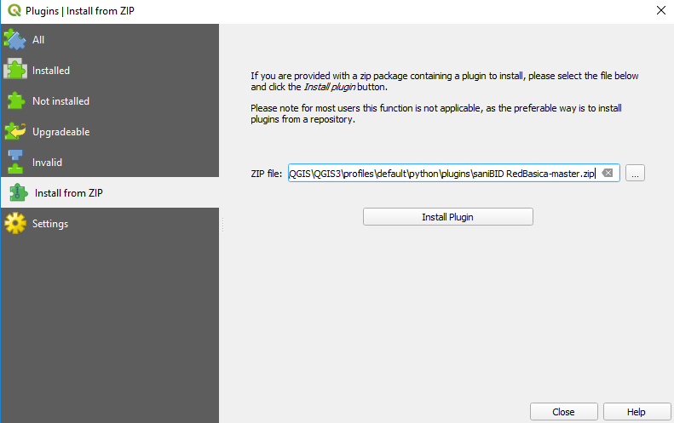

Once the plugin is installed, enable the tool display and the panel window through the menu View> Toolbar> SaniBID RedBasica and View> Panels> SaniBID RedBasica. With this the following tools and panel should be displayed.

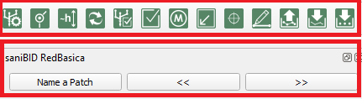

1.2 RedBasica Project and Layer Configuration

When a QGIS project file loads, you will see three base layers as examples. One raster layer, corresponding to the digital terrain model, and two vector layers, corresponding to contour lines of the project area and the cartographic base of the planned project area (block and lot division).

The layers and the project are configured for the Coordinate Reference System (CRS) EPSG: 32722 (WGS84 / UTM - 22S). For new projects, first configure the desired flat coordinate system and then save the QGIS project to a computer directory.

To configure the vector layers of the basic network and inspection devices (Inspection Boxes - IB or Manholes - MH) use the  button to select the New Layer option and enter a layer name for the segments. A vector layer of segments will be created in the Layers folder and automatically inserted into the project.

1.3 Setup for RedBasica Layout

Before beginning layout on the basic network, create a base for the area in question, including the block and plot plans and a topographic model of terrain elevation and contours.

The first step is to define the project area (drainage basins), identify the blocks within the area, and count the plots of each block for flow calculations. For this the  button is used, which will create the vector layer blocks.

The vector layers used for project assistance (blocks, pre1 and pre2) cannot be renamed by the user.

When the layer has been created, (1) select it (2) enable Layer Edit mode and (3) click on Add Point Feature, as shown below.

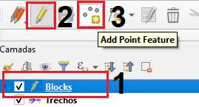

To add a new feature, left-click inside the block and fill in the attributes.

- ID_QE - Block identification;
- QE_IP - number of standard contribution units at plan start;
- QE_FP ​​-number of standard contribution units at plan end.

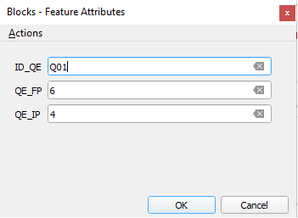

When the blocks have been identified and the lots have been counted, find and mark the points where water concentrates naturally on each block (low points, or block exits). These low points indicate where the basic collector network should run to facilitate the easiest connection of each block’s Condominial extension to receive that block’s contribution of sewage. For this, the  button creates the vector layer pre1. After the layer is created, select it and enable the layer edit mode and click on Add Feature (using the same steps used in the block layer).

To insert the arrows:
Left click on the desired location of the base of the arrow in the block;
Left click on the low point (lowest elevation) of the block, using the contour lines; Right-click to insert the arrow.

The illustration below demonstrates the blocks with arrows marking their low points in the project area. In this example, it is assumed that all lots (contribution units) will be occupied at the end of the plan and that the initial situation corresponds to 60% of occupied lots.

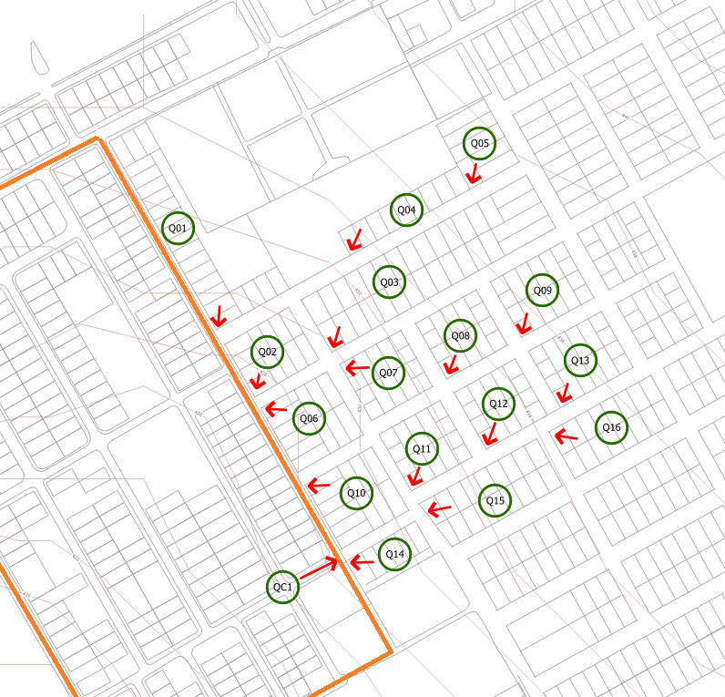

The QC1 feature represents a concentrated sewage flow equivalent to 2300 standard contribution units, representing the discharge of wastewater from the orange bounded area of ​​the map. This flow will be released into the basic collector network at the location indicated by the arrow.

1.4 Layout of Basic Network and Inspection Devices

With an equal number of lots for the start and end of plan and the location of the sewage contribution location of each block (Q01, Q02, Q03...) or concentrated flow (QC1) identified and marked, the layout of the basic sewage network can begin.

The basic collection network should run tangentially to the blocks, preferably passing through the lowest points, with an inspection device (IB or MH) located at the points marked to receive the sewage contributions (low point arrows).

To ensure that the segments connect correctly, enable the QGIS snapping tool via the menu:

Project> Snapping Options, check the Snapping option for the Active Layer only and select a Tolerance (4 meters recommended)

The advanced digitizing tool assists in extending the segments being plotted and can be enabled through the menu View> Panels> Advanced Digitization.

The maximum length of each segment varies according to local specifications. In the absence of better information, it is recommended to use between 80 and 100 meters.

To begin basic network layout:

1 - Select the layer of segments
2 - Enable the editing mode
3 - Enable the Add Feature tool and
4 - Enable the advanced digitizing tools

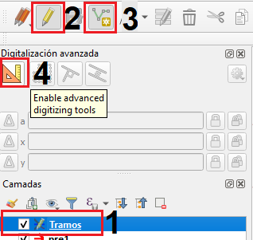

Enter the segment of the basic network with a left click, always upstream to downstream. Each click indicates where the collector vertex will be located (inspection devices - IBs and MHs), which in turn should coincide with the direction of the low point arrows. Right click to finish the layout of a collector.

For collectors with more than one segment, the following window will appear to label the collector segment name and the number of the first segment to be inserted. It is important not to label two collectors with the same name.

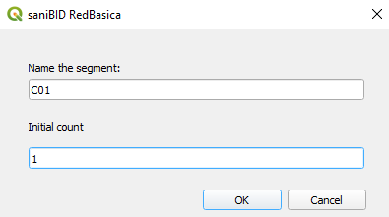

When clicking OK to confirm, be sure that the segments have been inserted. To display the collector and extension names, click the  button once to switch to plot mode click . Click again to return to drawing mode .

After drawing all the collectors, check that all the segments are correctly connected to each other using the button. This tool will select only the downstream most segment of the mapped network.
If any other segment is selected, then the downstream point will not match the upstream segment.

To make corrections in the drawing use the drawing editing tools of QGIS itself.

The tool can be used to move the vertices of the segments to ensure that the downstream point of that segment coincides with the upstream point of the next segment, ensuring an accurate connection between them. Another option is to erase and redraw the problem segments.

After verifying connectivity, insert the inspection devices at the vertices of the segments. This is done by clicking the  button and selecting, if there is one, the raster used to capture the terrain elevations.

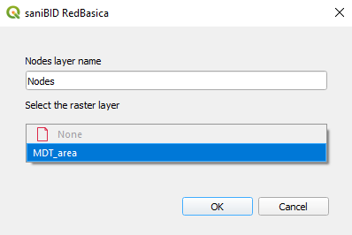

After the basic network has been drawn and the inspection devices inserted, it will look as shown below. The segments are labeled in black and inspection devices in red.
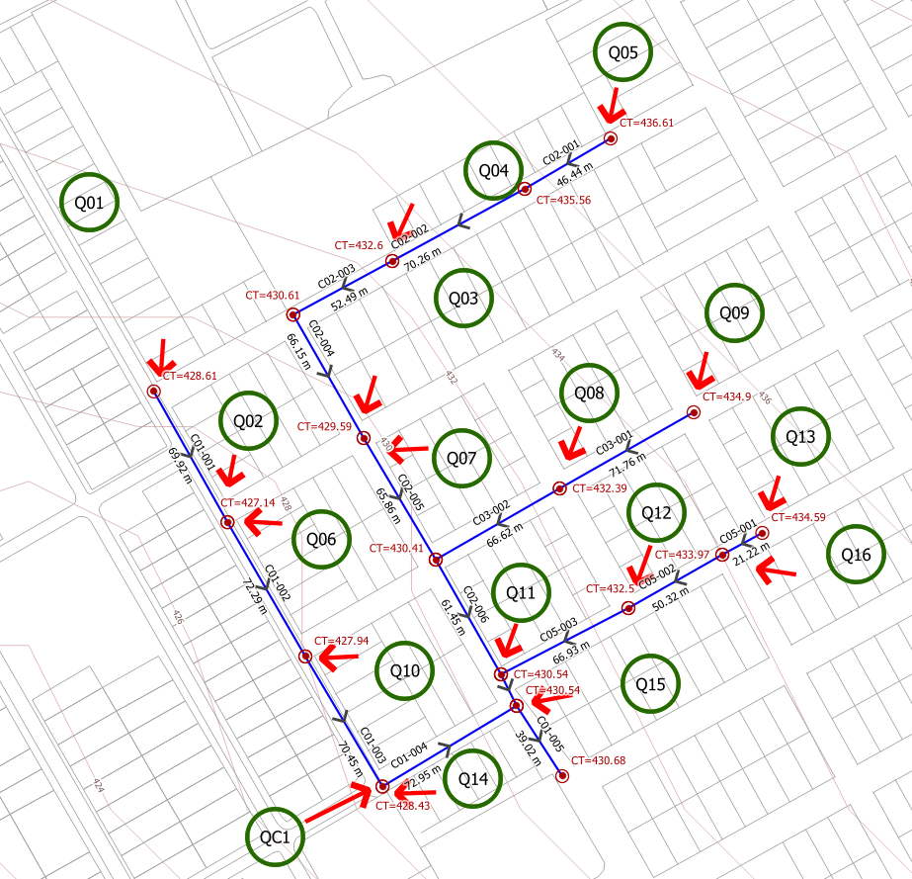
.
To name a collector with just one segment, or to rename any collector, select the vector layer of the segments and use the Name a Patch button located in the SaniBID window. Using the QGIS tool:

- Select the first collector segment to be named;
- Select the last collector segment to be named.

If the selected segments are connected correctly, a window will appear with fields to fill in the name and number of the first segment of the collector. If the collector has only one segment, select the segment twice.

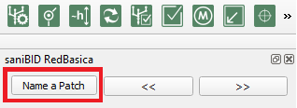

Segments which have been drawn can be erased, new segments can be added and the vertices of existing segments can be edited at any time using the tool, but it is important to repeat the verification operations and update the inspection devices after making any edits in the layout

1.5 Linking Contributing Units to Sections

The blocks or concentrated flow units that were previously defined in the Blocks layer must be linked to the segments which will receive their wastewater.
To do this, select the layer of segments. Using the tool select the desired collector and:

1 - Click on the Current Feature tab of the plugin panel;
2 - Enter the name of the block or concentrated flow that feeds into the segment at the upstream point into the ID_UC field;
3 - Click the >> button to save the edit and advance to the next segment.

If more than one block contributes to the same segment, enter the name of the two segments, separated by comma, as shown in the following image.

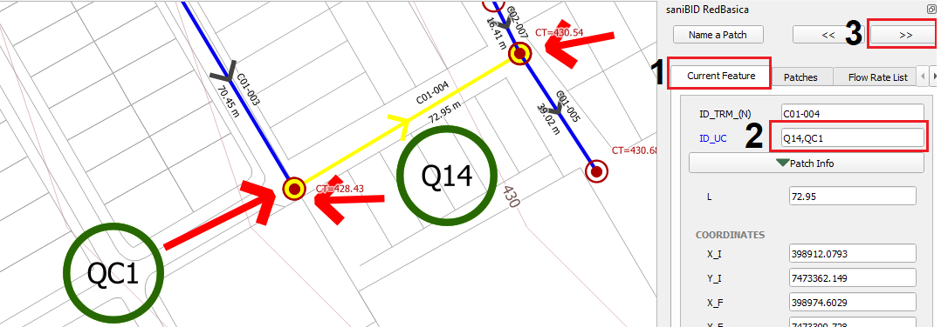

Use the list displayed on the Flow Rate List tab to verify that all the blocks and concentrated flows have been sent to their corresponding segments. After selecting the tab, click Refresh to create or update the list.

- The QE column indicates the name of the block or concentrated flow;
- Columns Ip and Fp indicate the number of contribution units for start and end of plan, respectively;
- The TRM column displays the name of the segment it is contributing to. The same contribution unit cannot contribute to more than one segment.

1.6 Exporting QGIS network data

To dimensioning the basic network after it has been drawn, the user should export the QGIS information to a .csv file with the button  and then load it into the spreadsheet provided with the plugin installer.

1.7 RedBasica - Calculations and Dimensioning spreadsheet

For the spreadsheet to work correctly in regions which use a comma to separate decimal numbers from integers:

- Click on the Enable Content option that will be displayed at the top to enable the use of macros;
- Go to the menu File> Options> Excel Advanced Tab and set the use of the decimal separators to “.” (dot) and thousands to “,” (comma).

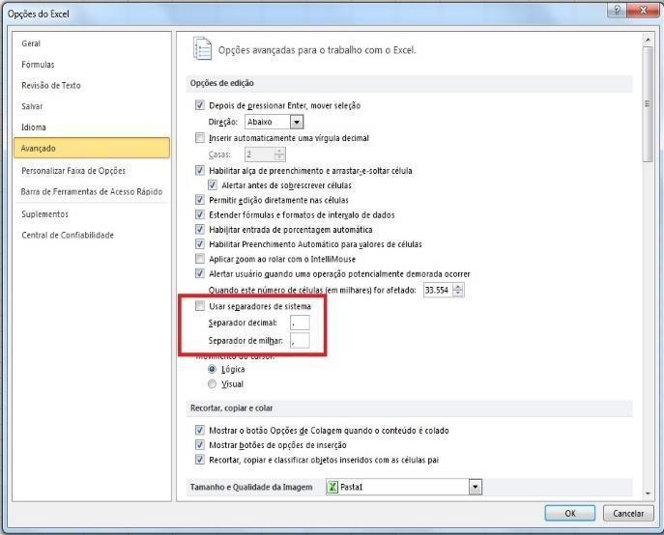

In the START tab, follow the following steps:

- Using the Import Data button, select the .csv file with the network data exported by QGIS and click Open;
- With the Load RB button, fill in the calculation and dimensioning sheet with the segments of the network that has been drawn;
- Fill in the project parameters, which are in the sheet that can be accessed by the Parameters Tab button.

The parameters used in the example are the spreadsheet default. To load them, use the Default Parameters button. The only change will be the occupancy rate of 4 inhabitants / household, as shown below. The values of all the cells in yellow can be changed as needed.

By default, flow calculations will be based on the number of standard contribution units reported in QGIS for the projected segments. To use the linear sewage contribution method, select the “yes” option in the parameters tab.

It is important to include the initial and final project populations and occupancy rates for the calculations to be performed correctly.

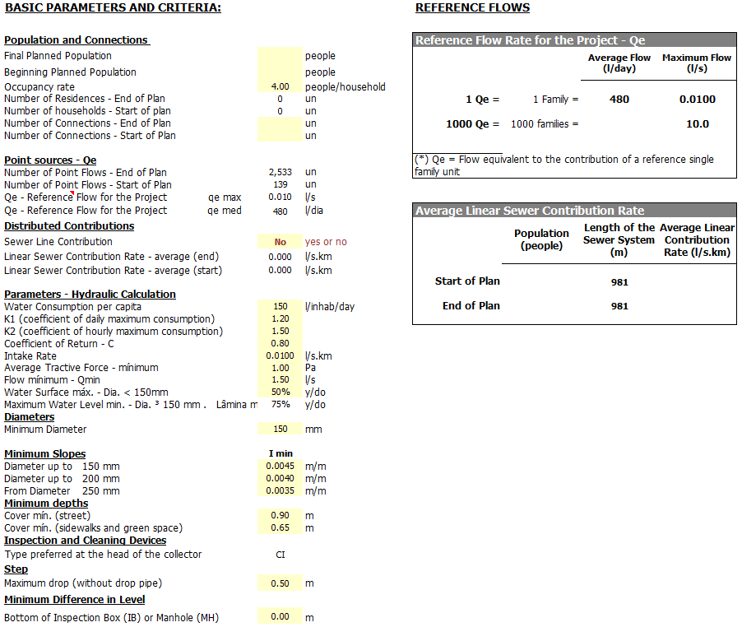

After it has been drawn, the sizing of the basic network is done in the RedBasica sheet, shown in the following illustrations. Each row represents a segment. Each column indicates, among other things, physical characteristics and flow rates of the system, and hydraulic flow conditions.

The sizing sheet optimizes the projected network, automatically searching for the shallowest possible depths for each segment, while adhering to the minimum depths and slopes established in the design parameters.

As in the parameter sheet, the columns in yellow can be edited manually.

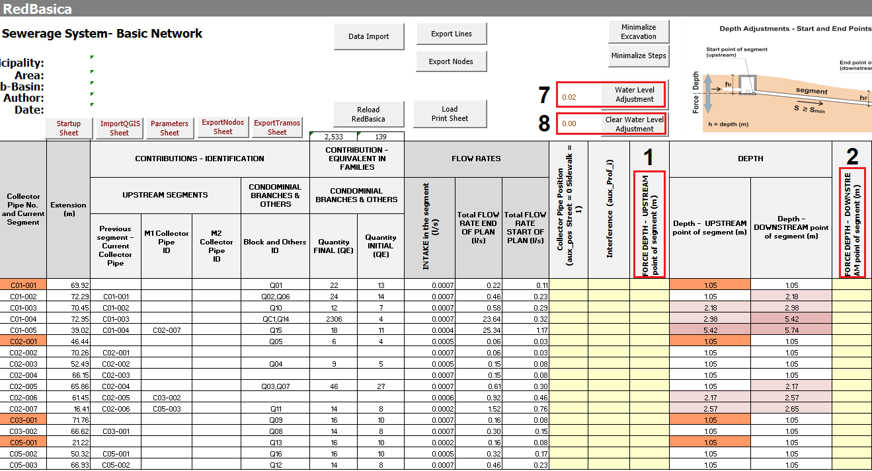

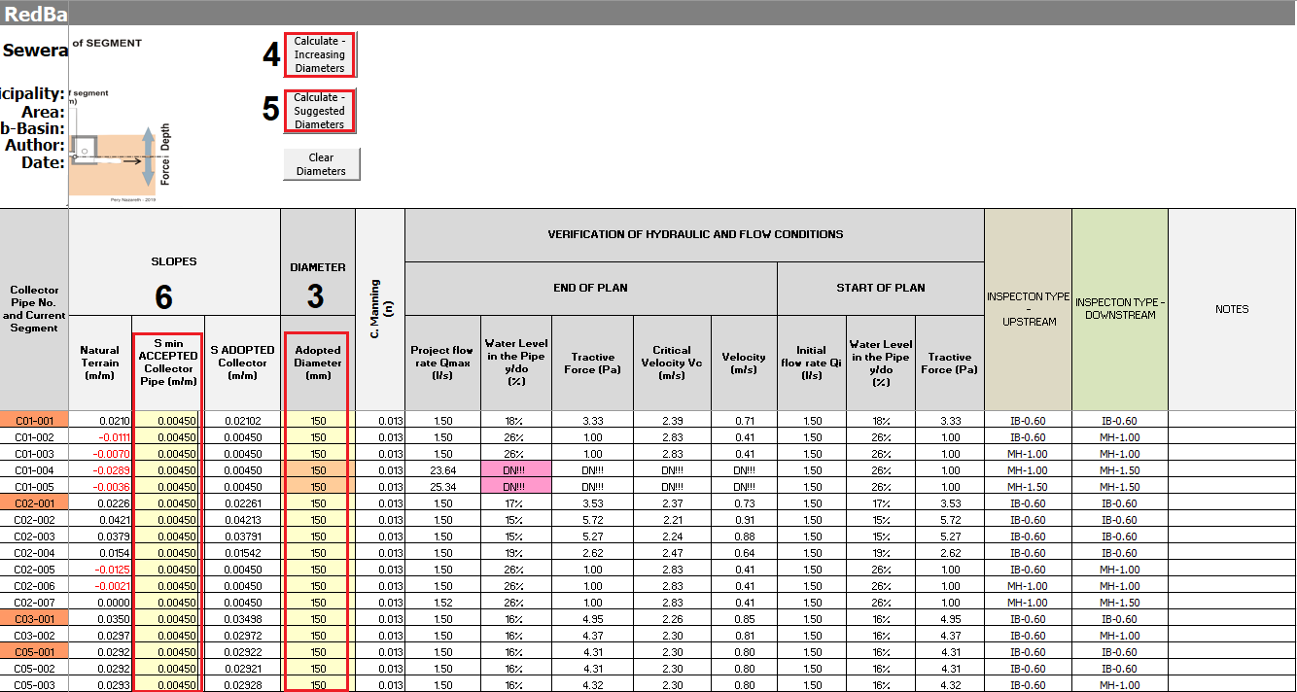

Columns 1 and 2 in the above image are used to manually force the depths of downstream and upstream segments. Depths entered manually will only be accepted by the system if they comply with the minimum slope parameters of the segment. Depths in downstream segments will be adjusted automatically.

Adjustments in the pipe diameter of each segment, when necessary, must be made by the user. There are three options for making these adjustments:

- Manual adjustment in column 3 – Adopted Diameter. It is important to use a diameter that is on the list of diameters displayed in the Parameters page of spreadsheet below the project parameters.
- Semi-automatic adjustment using button 4 – Calculate - Increasing Diameter, where the diameters in use will increase progressively. For example, if a segment of the collector has a diameter of 200mm, the downstream segments will have diameters equal to or larger than 200mm.
- Semi-automatic adjustment with button 5 – Calculate - Suggested Diameter which uses the diameter required for the flow conditions of each segment and may decrease in a downstream segment.

In the example shown, the collectors C01-004 and C01-005 need to have their diameters adjusted due to the QC1 concentrated flow that was added to the project. This information is available in the Water Level column, which displays the DN!!

Whenever there is non-compliance with the runoff conditions, the cell will be highlighted in pink.

Use button 4 – Calculate - Increasing Diameter to adjust the diameters of the collectors. In the example, using button 4 will increase C01-004 and C01-005 to a diameter of 250 mm.
With the adopted diameters, the tractive tension in segments C01-004 and C01-005 at the start of the plan is highlighted in pink (0.75), indicating that the drag force in these segments is lower than the minimum (1 Pascal). To make the necessary adjustments, increase the slope value using button 6 - S min ACCEPTED Collector Pipe.

Lastly, adjust the water level in the collectors to avoid Sewage backflow. This is done using the 7 - Water Level Adjustment button. This adjustment should be made whenever the cell on the left side of the button displays a non-zero value.

Changes in diameters, slopes, depths and water level influence runoff conditions. Whenever changes have been made to the spreadsheet be sure to check the columns for hydraulic verification and flow conditions. The last adjustment should always be the water level, when necessary.

If additional adjustments are made to the diameter or minimum slope of the segment after the water level adjustment, use the 8 - Clear Water Level Adjustment button, and then use the 7 - Water Level Adjustment button again.

When no further adjustments are required, print the spreadsheet calculation history and export the dimensioning results to QGIS.

1.8 Printing Calculation History and Exporting Results to QGIS

The Calculation History print sheet is generated by the Generate Print Sheet button, and by default is set for A3 format printing.
The Export Lines and Export Nodes buttons on the RedBasica spreadsheet are used to generate two .csv files containing the segment information and the sized inspection devices. These files will later be loaded into the project plotted in QGIS.

Importing spreadsheet data into QGIS

When the .csv files have been generated, use the button in QGIS to import the .csv file results for the segments and the button to import the .csv file results for the inspection devices.

The information will be stored in the attribute table of the respective vector layers. The information set of a segment and its upstream and downstream nodes can be viewed by selecting the desired segment and opening the Current Feature tab in the SaniBID RedBasica panel.
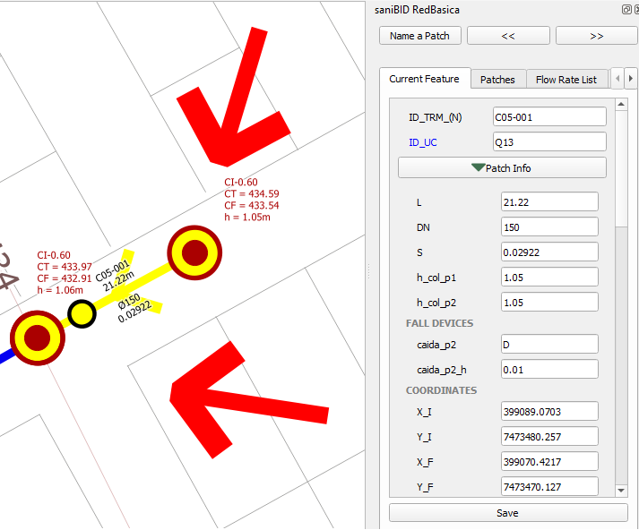

Project information can be displayed on the QGIS map by switching from Drawing Mode to Plot Mode . In Plot Mode, the black labels indicate segment information and the red labels indicate node information.
Plot Mode labels are illustrated in the figures below.
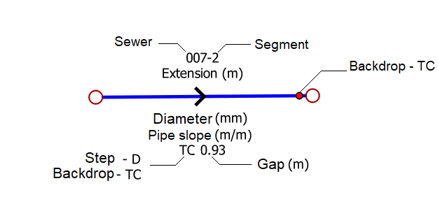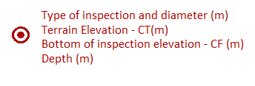
To change the labels, use the tools in QGIS. To enable, use the menu View> Toolbar> Label.
To move an inspection device label, select the layer of the nodes, enable edit mode and use the tool, dragging the label to the desired location with the left mouse button.

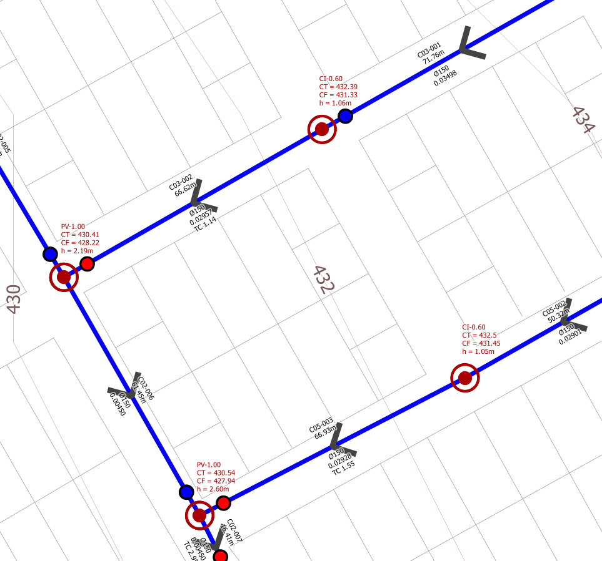

1.10 Printing a project in QGIS
Create a print layout in the manner desired, or use two pre-configured layouts for A0 sheet printing, available in SaniBID RedBasica.
To load the plugin's print page, click on the Show Layout Manager button. On the Layout Manager tab click on New From a Template. Select the Specific option and indicate where the print composer is located.

There are two pre-configured layouts in the Print folder that is created by the plugin, located in the same folder as the current project. They are the Compositor_A0_Horizontal and Compositor_A0_Vertical files.

After selecting the desired layout, click Create, choose a name for the print composer, select it, and click Show.

To display the project area on the loaded print composer, either click on the Map area on the composer or select Map 1 in the Items window (shown on the right in the illustration below), then select the Item Properties tab. In the Extents menu use the Set to Map Canvas Extent button.
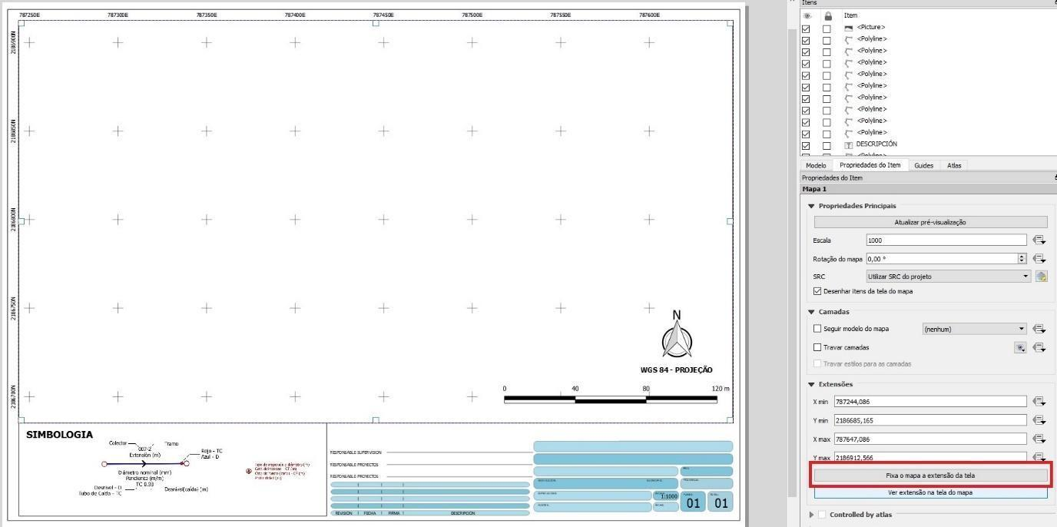

To print the sheet, click Draft Menu and go to Print Layout. To export the print page to an image or PDF format, click Export as Image or Export as PDF.

REFERENCES

MARA, D. D. (1996). Low-cost sewerage. Wiley, Chichester, UK.
MARA, D. D.; SLEIGH, Andrew (2001). PC-based Simplified Sewer Design. School of Civil Engineering, University of Leeds. Leeds, UK.
MELO, J.C. (2005). The Experience of Condominial Water and Sewerage Systems in Brazil - Case Studies from Brasilia, Salvador and Parauapebas. World Bank, BNWP, WSP.

RÊGO, R.C.F. et al. (2018) Impacto de um programa de saneamento ambiental na saúde : fundamentos teórico-metodológicos e resultados de pesquisa interdisciplinar. EDUFBA. Salvador, Bahia.

COLLABORATORS

Programming Analyst - Ticiano Bragatto

